**Assessment Task**

**Create a home page with all the following sections which are mentioned below:**

1. Navbar



1. Hero Section

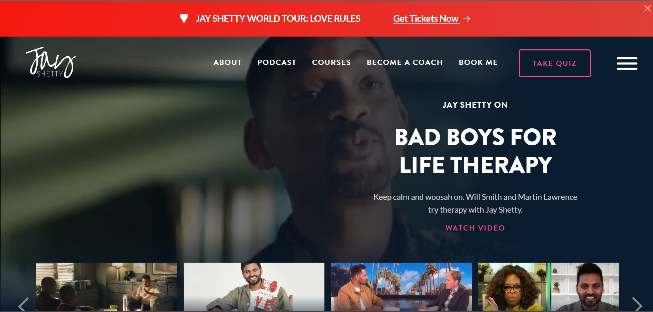

1. “HERE'S HOW JAY CAN HELP” – Section

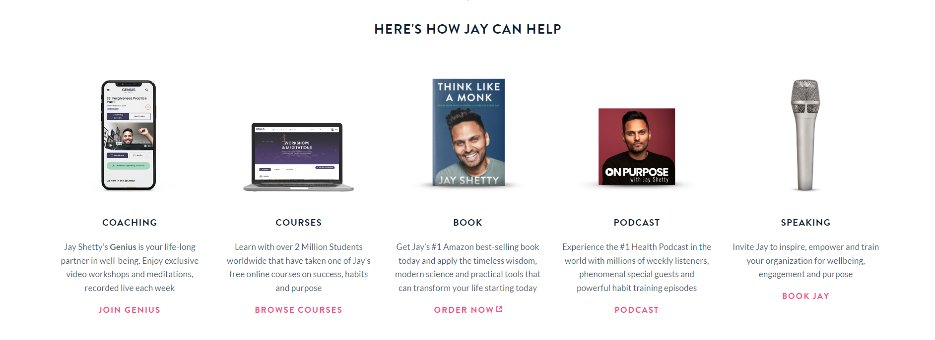

1. Footer

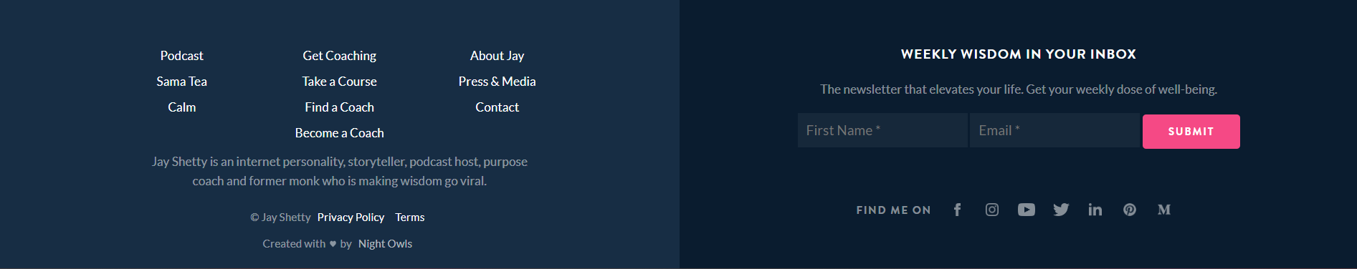

Notes:

For reference:

<https://jayshetty.me/>

Part of task:

1. Your page should be responsive for Desktop & Mobile
2. Menubar functionality should work as working on the live page.
3. For Hero section use static image
4. For carousel(slider) over hero section use Splide.js library
5. ALL THE BEST !!!
6. Use as less custom css as possible and use more Bootstrap class
7. Use css variables concept.
8. Proper “classname” – naming convention should be followed. Class name used should be relevant to the component.
9. You should deliver the project by EOD.
10. For all the images used on the website use the link from website, if download sample image or take screenshot from the webpage itself and include in the “media” folder.
11. I am including the template folder.

Traits of a good Coder:

1. Use less number of lines of code
2. Use relevant naming for classes
3. Give proper comments wherever needed.

Reach us for any further query or clarification.